ENTERPRISENETWORK WITH SITE TO SITE VPN
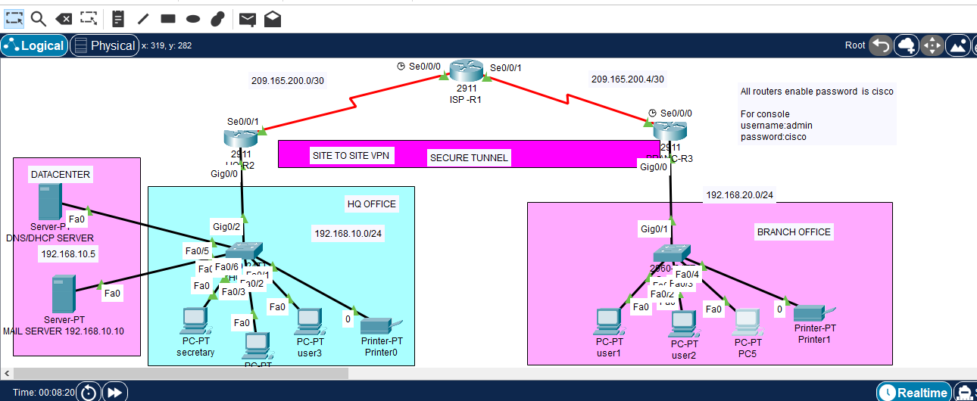
Communication from HQ mail server to Branch LAN
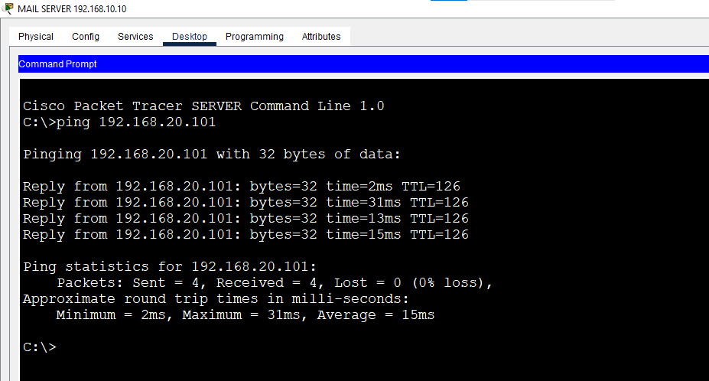
LAN pc to Mail server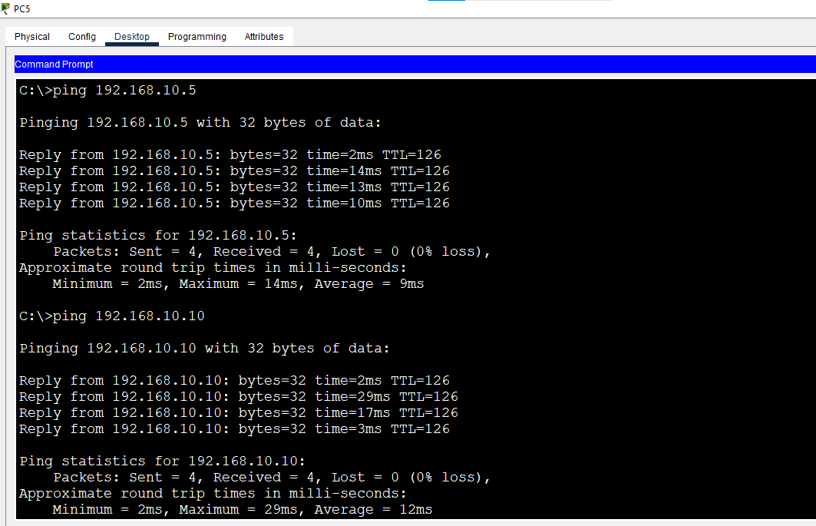
IPSec Vpn Data encryption as from HQ to BRANCH
To verify and see how the Site to site VPN tunnel encrypts data use
Show crypto ipsec sa
